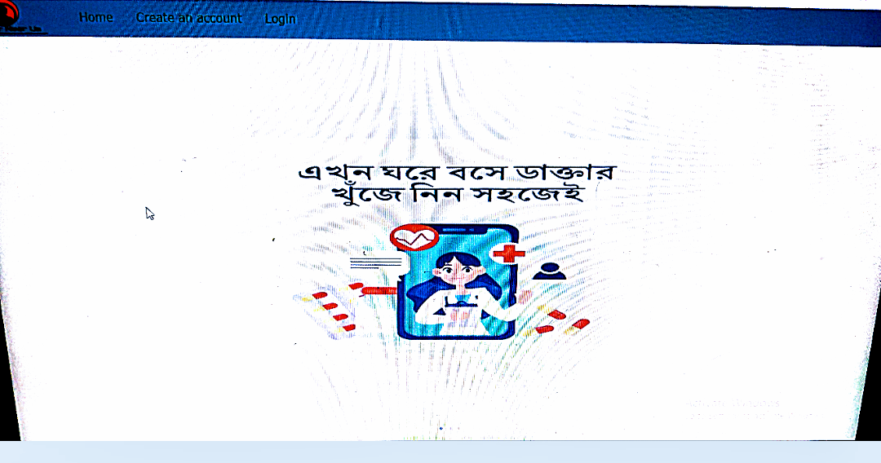

FRONT END = HTML,CSS, MYSQL WHICH IS USED AS DATABASE

BACKEND= PHP

THE MAIN PURPOSE OF OUR PROJECT TO TO GET TREATMENT AND FIND DOCTORS THROUGH ONLINE AND TO GET MEDICAL REPORTS AND HISTORY THROUGH ONLINE WHICH IS VERY BENEFICAL FOR COVID19.

FOR TO LOGIN IN THIS WEBSITE DOCTOR’S AND PATIENT’S MUST BE AN REGISTERED HOLDER OF THE WEBSITE AND WE HAVE EXPORT DOCTOR AND PATIENT INFORMATION FROM DATABASE.EMAIL IS USED AS A PRIMARY KEY AND SOMETIMES EMAIL USED AS A FOREIGN KEY.

DOCTOR

DOCTORS CAN ADD THEIR CHAMBERS ONE OR MORE THAN ONE .HE CAN EVEN ALSO ADD HIS SPECIALISATION ONE OR MANY. HE CAN ONLY SEE PRESCRIPTION OF HIS/HER PATIENTS ONLY BUT NOT ALL THE INFORMATION OF THE OTHER PATIENTS.HE CAN SEE WHICH PATIENT APPOINTED TO HIS CHAMBER. DOCTORS PASSWORD IS SAVED AS A HASHCODE IN DATBASE. FOR TO LOGIN HE NEEDS TO USE HIS/HER EMAIL BY WHICH HE CREATES AND ACCOUNT.DR ID IS USED AS A PRIMARY KEY . THE EMAIL ONCE THE DOCTOR HAS REGISTERED CANNOT USE THE SAME EMAIL AGAIN TO GET REGISTRATION AGAIN.

PATIENT

PATIENT CAN SEARCH THE DOCTOR BY THE AREA DR LIVE IN OR ELSE HE/SHE CAN FIND DOCTORS OF THE OTHER AREA AS WELL.THROUGH ONLINE PATIENT CAN GET MEDICAL CHECKUP AND SEE HIS/HER PRESCRIPTION ALSO .DR CAN UPLOAD THE PRESCRIPTION. THROUGH ONLINE HE/SHE CAN CREATE HIS/HER OWN APPOINTMENT.

PROBLEMS WE FACED

WE FACED THE PROBLEM IN CONNECTING PHP WITH DATABASE.

WE HAVE SEVERAL BUCKS.WE ALSO HAVE TAKEN HELP FROM W3SCHOOL AND YOUTUBE AS WELL.

Reference: W3SCHOOL,YOUTUBE(MAINLY 80% FROM YOUTUBE)